Electronics Documentation

1. Electronics Block Diagram
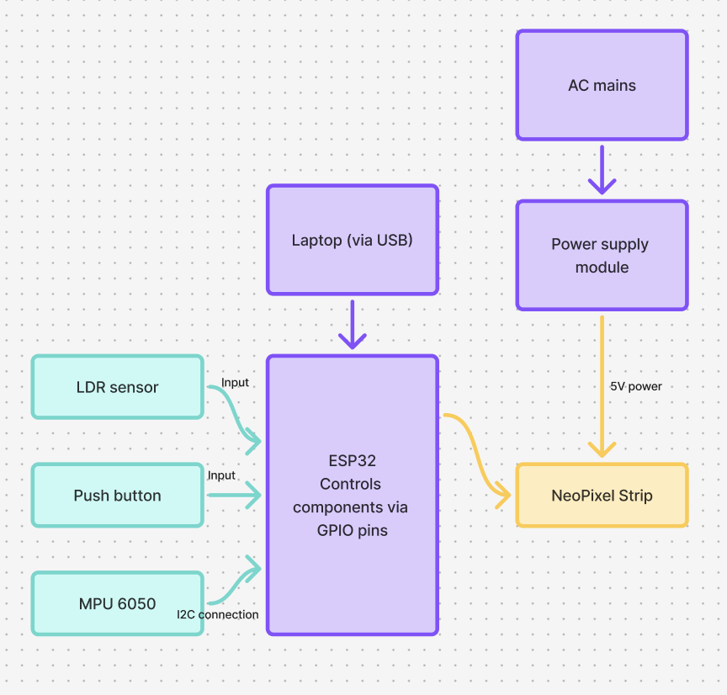
Made on FigJam

2. Components Table
Component | Quantity | Purpose | Justification
NeoPixel strip | 1 (60 LEDS, 1m) | To provide the light sequence for the lightsaber | Contains RGB LEDs that can be controlled independently from the microcontroller to create custom animations
Light Dependent Resistor (LDR) | 1 | Detects darkness to activate the light sequence  Done when the user puts their hand around the hilt | The LDR can be used as an input when darkness is detected, which is why we positioned it on the hilt so the light sequence switches on instantaneously when touched by the user
Push Button | 1 | Input to cycle through 4 different colours on the NeoPixel | As a manual switch, it will allow the users to activate a colour of their choice by closing the circuit when pushed
MPU 6050 | 1 | Used to turn the lightsaber into a gesture controller for the browser game | Motion-tracking sensor with a gyroscope and an accelerometer to send user’s wrist orientation, acceleration and rotation data to ESP32 to match the movement to the game
ESP 32 | 1 | Stores and controls all the tasks coded for the other components | Since it has integrated Wi-Fi capabilities, we were able to create a browser based game
Power Supply Module | 1 | Connected to the NeoPixel strip to provide power | Provides the required 5V DC supply to the NeoPixel strip
Justification is important

